Calum Kerr

1. Requirements Specification 3

1.1. Functional Requirements 3

1.2. Non-Functional Requirements 3

2. Design Specification 3

2.1. Colour scheme and font 3

2.2. Wireframes 3

2.3. Design of booking form/page 3

3. Timeline 3

# Requirements Specification

### Functional Requirements

* The user will input their data into a registration form, such as their name, second name, username, and password. After submitting it is then sent to the database where the information is kept. Once the user has inputted their data, they are now able to login. They do this by accessing the login form and inputting their username and password. This data is collected from the database, and if the information matches the username and password then they will be allowed to enter. However, if it doesn’t match then they can’t enter.
* What information for registration will be collected?
* First name
* Second name
* Username
* password

### Non-Functional Requirements

* The language used was ‘HTML’ to make the website, and within it there was a second webpage scripting language called PHP. HTML which stands for “Hypertext Markup Language” and PHP stands for "Hypertext Preprocessor."
* The software required to develop the software is ‘notepad++’ and Xampp, which will execute PHP on local server. In order to see the registration-form it had to be shown on MySQL in the database, where it was stored.

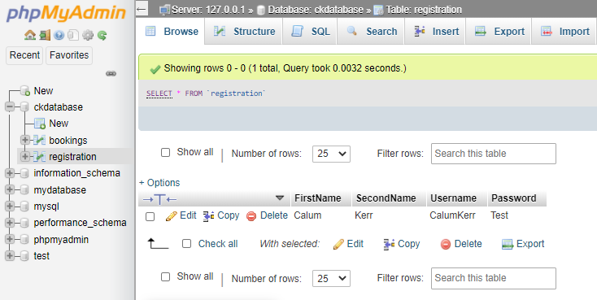

* This shows where the information is being sent after the user inputs their data.
* 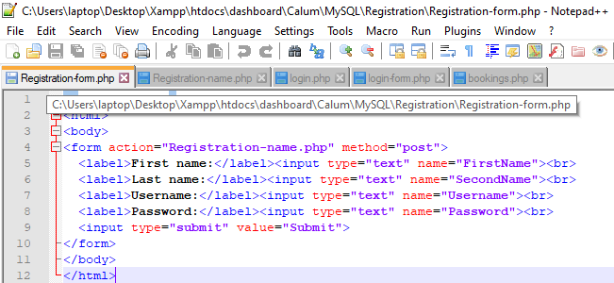This shows the form that the user will input their data, on notepad++.

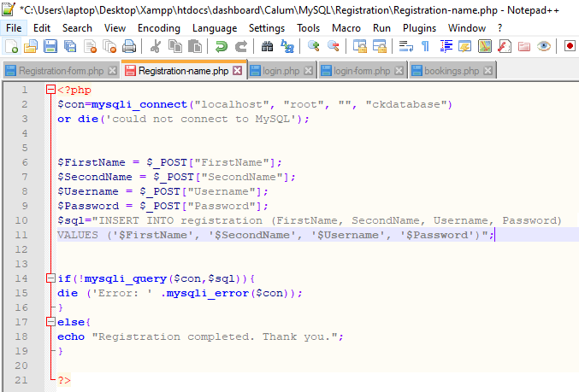

* This is the script that runs the registration form.

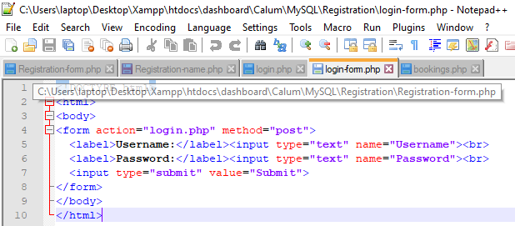

* This shows the php form for the login system.

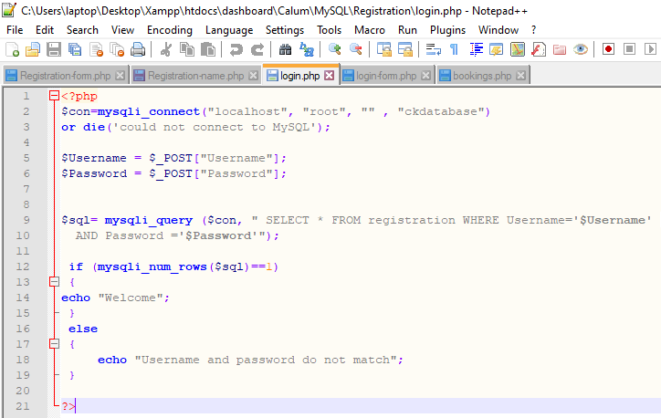

* This shows the script that runs the login page.

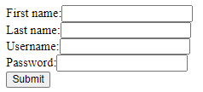

* This is where the user inputs their data which will then be sent to the database.

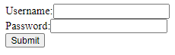

* This is where the user inputs their username and password, the information is collected from the database and will allow the user to enter but if the information doesn’t match in the database, then it won’t allow them to enter.

# Design Specification

### Colour scheme and font

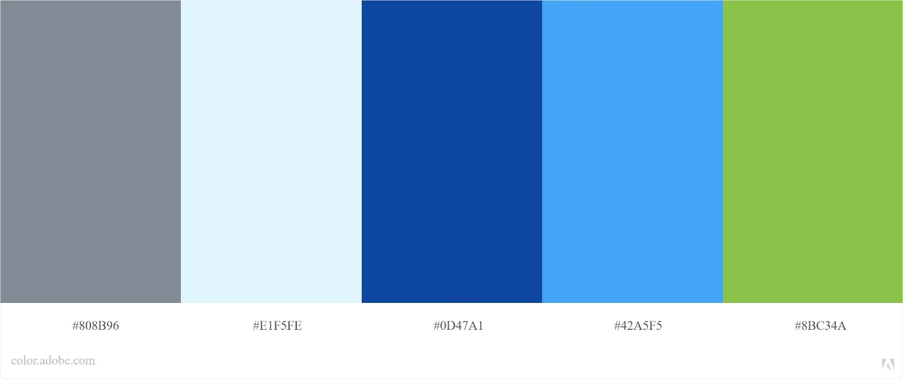

<link href="https://fonts.googleapis.com/css2?family=**Open+Sans:wght@600**&display=swap" rel="stylesheet">

CSS (font-family: 'Open Sans', sans-serif;)

### Navigation Map

### Wireframes

### 

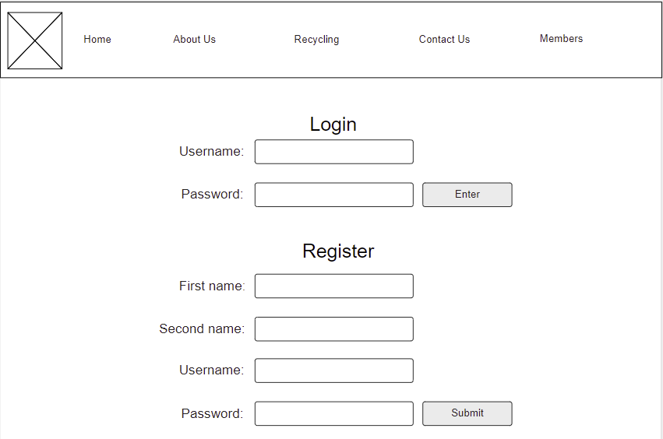

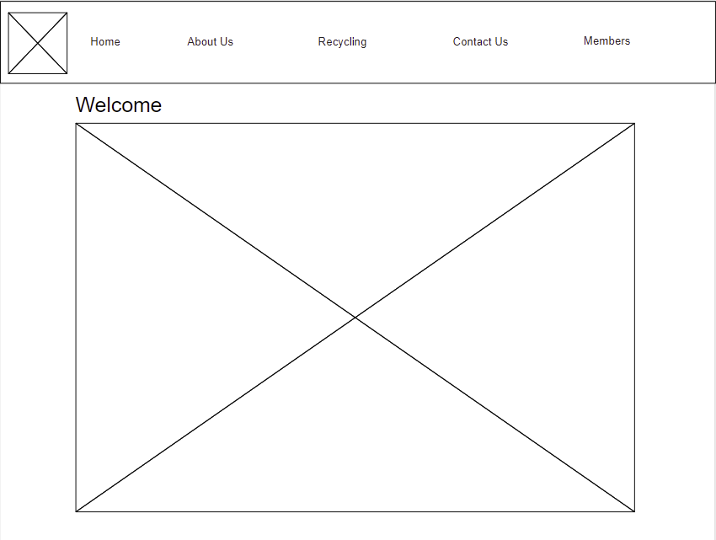

# Timeline

